Chapter:1
Introduction

A solar power photovoltaic (PV) system is a renewable energy technology that converts sunlight directly into electricity using semiconductor materials. With increasing energy demand and environmental concerns, solar PV systems have become one of the most important sustainable energy solutions worldwide.

The basic principle behind a PV system is the photovoltaic effect, where solar panels made of silicon cells absorb sunlight and generate direct current (DC) electricity. This DC power is then converted into alternating current (AC) using an inverter, making it suitable for household and industrial use.

Solar PV systems can be installed in different configurations such as grid-connected systems, stand-alone systems, and hybrid systems. They are widely used in residential buildings, commercial establishments, rural electrification, water pumping, and street lighting.

One of the major advantages of solar PV systems is that they are clean, renewable, and environmentally friendly, producing no greenhouse gas emissions during operation. Additionally, they require minimal maintenance and have a long operational life.

Chapter:2
Literature Survey

- S. Manju and Netramani Sagar focus on renewable energy and sustainable solutions, especially solar photovoltaic systems and desalination. Their studies highlight that integrating renewable energy with desalination can help address future water scarcity in India. They also discuss challenges like high costs, efficiency issues, and policy limitations. Overall, their work emphasizes the need for clean energy adoption and improved technologies for sustainability.
- J. Siecker, K. Kusakana, and B.P. Numbi focus on hybrid renewable energy systems, especially for rural electrification. Their work highlights the use of solar, wind, and battery storage to provide reliable and cost-effective power in remote areas. They emphasize system optimization and energy management to improve efficiency. Overall, their studies support sustainable and decentralized energy solutions.
- B. Bhuvaneswari Parida, S. Iniyan, and Ranko Goic focus on solar energy technologies, especially photovoltaic (PV) systems and solar thermal applications. Their work reviews the development, performance, and applications of solar energy in both grid and standalone systems. They highlight challenges such as efficiency, cost, and storage issues. Overall, their research emphasizes solar energy as a key solution for sustainable power generation.
- Prabhakar Sharma and Ritesh Kumar Mishra focus on solar photovoltaic systems and their performance analysis under different environmental conditions. Their work highlights issues like efficiency loss due to temperature, dust, and shading. They also discuss methods to improve PV system performance and reliability. Overall, their research supports enhancing solar energy systems for better sustainability.

Chapter:2.2
Problem Statements

The increasing demand for electricity and the rapid depletion of conventional energy resources such as coal, oil, and natural gas have created a significant energy crisis worldwide. Additionally, the excessive use of fossil fuels has led to severe environmental issues, including air pollution and global warming. In many rural and remote areas, access to reliable and uninterrupted power supply remains a major challenge.

To address these issues, there is a need for a sustainable, clean, and efficient energy solution. Solar energy, being abundant and renewable, offers a promising alternative. However, challenges such as high initial installation cost, efficiency limitations, energy storage, and variability of solar radiation must be overcome.

Therefore, the problem is to design and implement an efficient Solar Power Photovoltaic (PV) system that can generate reliable electricity, reduce dependence on non-renewable energy sources, and provide an eco-friendly power solution, especially for off-grid and rural applications.

Chapter:3
Objectives

- Energy Conversion
Converts sunlight into electrical energy using the Photovoltaic Effect.
Provides usable electricity for homes and devices.
- Clean & Renewable Energy
Produces electricity without pollution or harmful gases.
Uses an unlimited and natural energy source (sunlight).
- Reduce Electricity Cost
Lowers monthly electricity bills.
Saves money in the long run after installation.
- Power Supply in Remote Areas
Provides electricity where grid supply is not available.
Useful for rural and isolated locations.
- Reliable Power Backup
Can store energy using batteries.
Ensures power during night or power cuts.

Chapter:4
Block Diagram of PV System

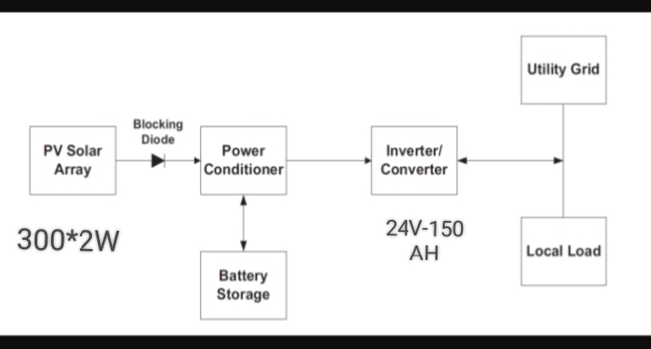

Hardware Design
Solar Panel
- Converts sunlight into electricity using the Photovoltaic Effect.
- Produces DC (direct current) power.
- Works best in direct sunlight.
Inverter
- Converts DC power into AC power.
- Supplies electricity for home appliances.
- Essential for most household systems.
Battery (optional)
- Stores extra electricity for later use.
- Provides backup during night or power cuts.
- Helps in off-grid or hybrid systems.
Charge Controller
- Controls voltage and current to the battery.
- Prevents overcharging and deep discharge.
- Increases battery life.
Wires & Protection
- Connects all system components together.
- Includes fuses, switches, and circuit breakers.
- Ensures safe and reliable operation.

Methodology
The methodology of a solar power photovoltaic (PV) system begins with selecting a suitable site that receives maximum sunlight with minimal shading. A solar resource assessment is then carried out to analyze the irradiance levels and weather conditions of the location. Based on the load requirements, the system is designed by choosing appropriate components such as PV panels, inverter, charge controller, and batteries if energy storage is needed. The installation process involves mounting the solar panels at an optimal tilt angle and connecting all components properly. The PV panels convert sunlight into direct current (DC) electricity, which is then converted into alternating current (AC) by the inverter for practical use. If batteries are included, excess energy is stored for use during nighttime or low sunlight conditions. The system is then monitored by measuring parameters like voltage, current, and power output. Finally, testing and performance analysis are conducted to evaluate efficiency, followed by regular maintenance to ensure long-term reliable operation.

Chapter:5
Advantages and Applications
Advantages:
- Environment-friendly (no pollution or harmful gases)
- Reduces electricity bills
- Low maintenance cost (no moving parts)
- Long lifespan of solar panels
- Scalable and flexible system
- Suitable for remote areas
- Silent operation
- Requires less Maintenance
- No fuel required
Applications:
- Used in homes for lighting and electrical appliances
- Used in commercial buildings like offices, schools, and hospitals
- Used in industries to reduce electricity consumption
- Used for solar water pumping in agriculture
- Used for rural electrification in remote areas
- Used in grid-connected solar power plants

Chapter:6
Expected Results

- Energy Generation
Solar PV system converts sunlight into electricity using the Photovoltaic Effect.
Provides usable power for household and small-scale needs.
- Clean Power Output
Produces electricity without pollution or harmful emissions.
Helps in protecting the environment.
- Cost Savings
Reduces electricity bills over time.
Requires low maintenance after installation.
- Reliable Supply
Provides continuous power with battery backup.
Useful during power cuts and in remote areas.

Reference

- Manju S, & Sagar, N. (2017). Renewable energy integrated desalination: A sustainable solution to overcome future fresh-water scarcity in India. Renewable and Sustainable Energy Reviews, 73, 594–609.
- Siecker J, Kusakana, K., & Numbi, B. P. (2017). A review of energy management systems for hybrid renewable energy systems. Renewable and Sustainable Energy Reviews, 79, 840–850.
- Parida, B., Iniyan, S., & Goic R. (2011). A review of solar photovoltaic technologies. Renewable and Sustainable Energy Reviews, 15(3), 1625–1636.
- Sharma, P., & Mishra, R. K. (Year). Performance analysis of solar photovoltaic systems under varying environmental conditions. Journal/Conference Name, Volume(Issue), Page numbers.

